No internet connection when 4G LTE router in 4G mode with SIM card inserted
First, we need to login in the management UI, ‘Open browser’ -- ‘Type 192.168.0.1’ -- ‘The default password is ‘admin’’ or double click to run the program ‘’
- Confirm whether the connection status is closed, If off, just turn on it.
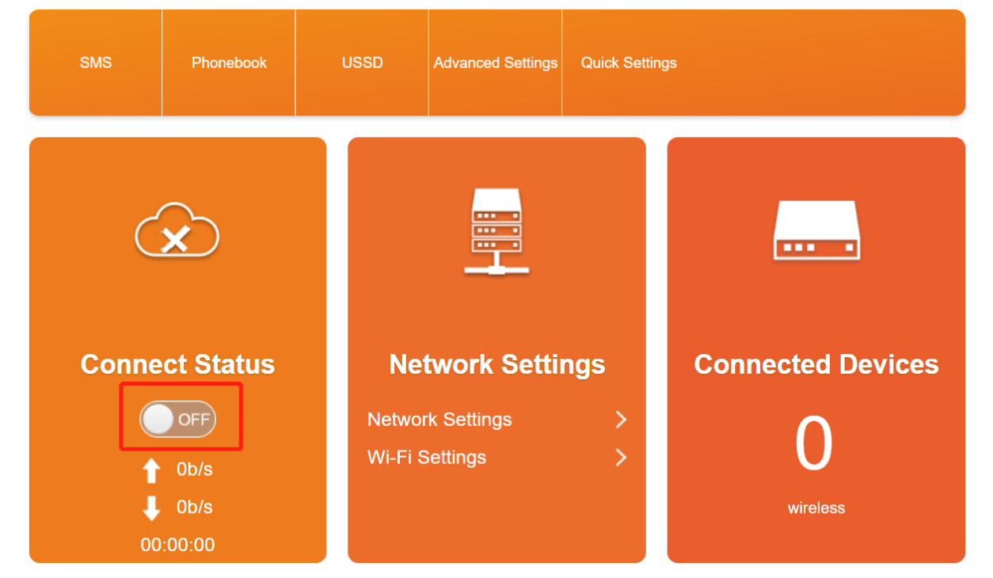
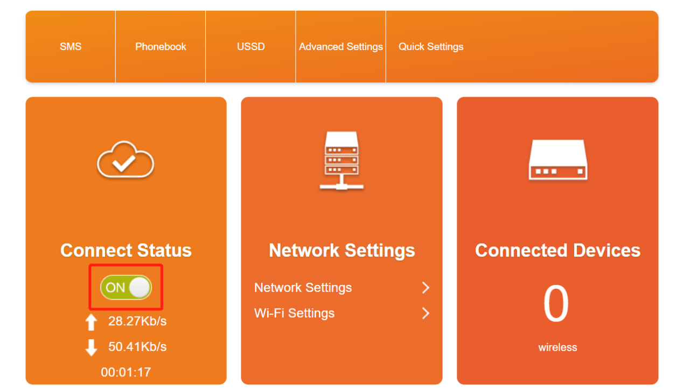
- Check if the APN information is correct
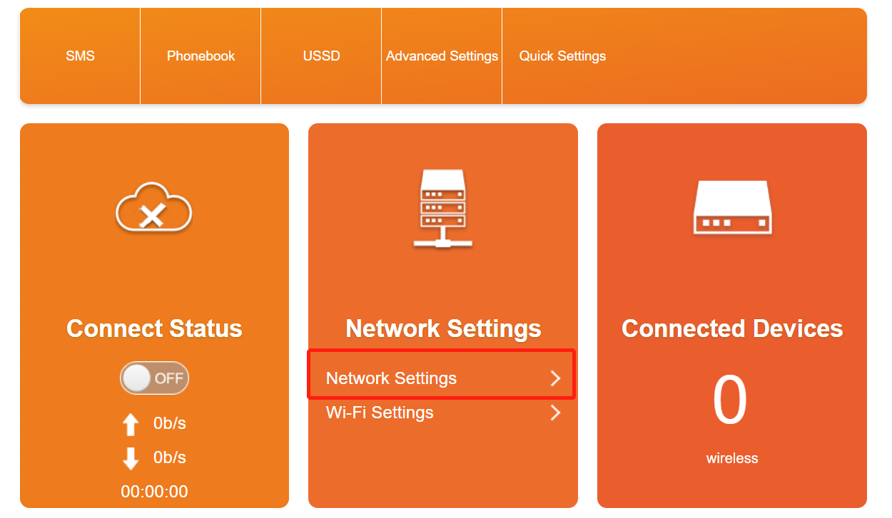
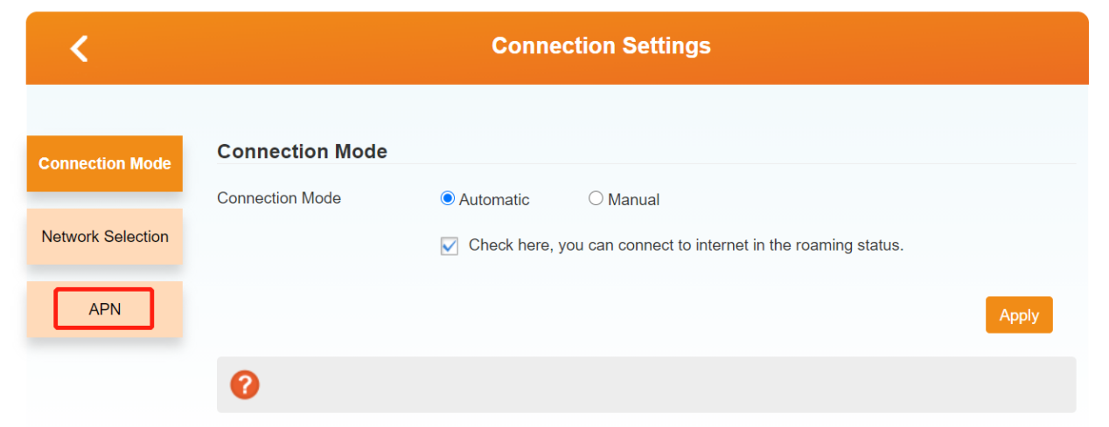We can refer to this link: https://youtu.be/N6LXeljdP3c to compare the APN information queried by inserting the sim card into the Android phone with the APN information identified by the device. If not,we can create a new profile to add the correct APN information, please refer to this link: https://youtu.be/0oUfrb1Fvww

- Check whether the flow limit is set
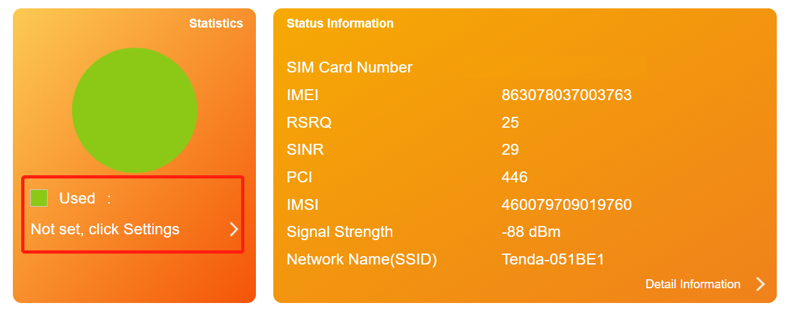
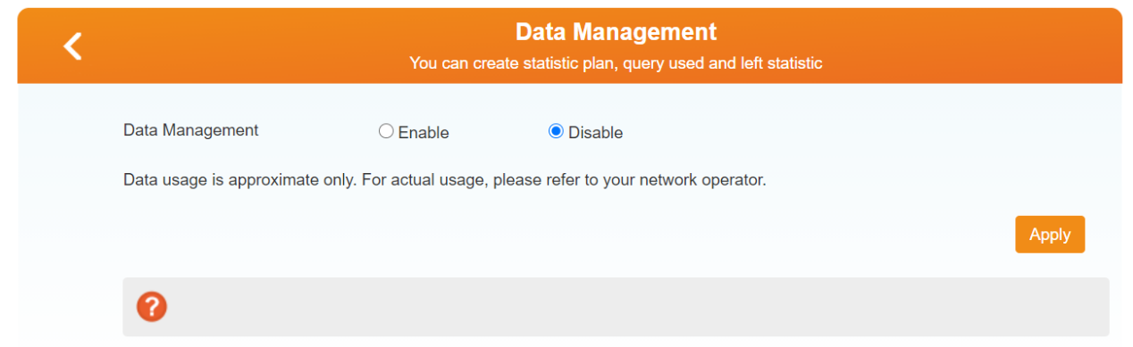

- Insert the SIM card into the mobile phone to test whether it get internet normally

If you encountered other situations not described above, please update your router’s firmware or contact our tech support by send E-mail to support@tenda.com.cn

